 VINOD SIR’S GROUP TUTION

MARKS: 20 IX-MATHS-II TIME: 1 Hr. 30 Mins.

Q. 1: Do as directed:
1. 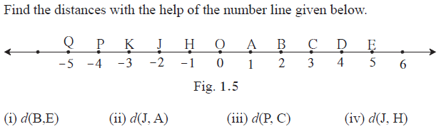 [4]
2. 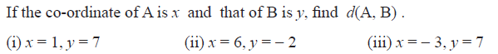 [6]
3. On a number line, points A, B and C are such that d(A,C) = 10, d(C,B) = 8 Find d(A, B) considering all possibilities. [2]

4. Points X, Y, Z are collinear such that d(X,Y) = 17, d(Y,Z) = 8, find d(X,Z) .
[2]

5. Point M is the midpoint of seg AB. If AB = 8 then find the length of AM.
[1]

6. If AB = 5 cm, BP = 2 cm and AP = 3.4 cm, compare the segments. [1]

7. Answer the question from the following: [3]

Find d (U,V), d (P,C), d (V,B), d (U, L).

8. If the points are not collinear, state so. [1]
d(P, R) = 7, d(P, Q) = 10, d(Q, R) = 3

